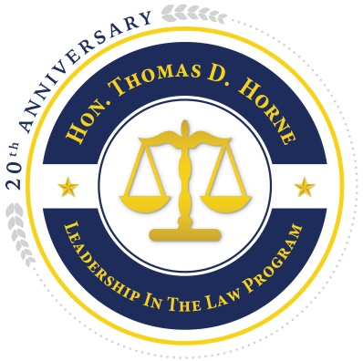
HON. THOMAS D. HORNE
LEADERSHIP IN THE LAW PROGRAM 2020

Application
Administered by the Loudoun Bar Foundation
Camp Dates: June 21 - 26, 2020

Please fill out this form using blue ink and mail it to:
Hon. Thomas D. Horne Leadership in the Law Program
Attn. Penn Bain
Sevila, Saunders, Huddleston & White, P.C.
30 N. King Street
Leesburg, VA 20176

Name
Age/DOB
Male Female
Parent/Guardian’s Full Name
Street Address
City/State/Zip
Parent/Guardian’s Home Phone
Parent/Guardian’s Work Phone
Parent/Guardian’s E-mail Address
Name of Your High School
Current Year in School
Name of Your US History Teacher
Extracurricular Activities & Years Participated. Please attach written list.
Do you speak any language other than English?
If yes, how many years have you spoken/studied each?
ATTACHMENTS:
- Tell us the most interesting thing about you, the most interesting thing you’ve ever done or the most interesting place you’ve ever been. (Please attach your answer/statement to this application.)
- We recommend that you attach a letter of reference from a teacher, coach, or other adult who will recommend your participation in this program.

SPECIAL NEEDS FORM (Please attach a separate sheet if needed to accommodate your response(s.):

- Will you require wheelchair accessible accommodations? yes no
- Will you need the use of a wheelchair at all meetings? yes no
- Do you have any special dietary needs? yes no If yes, please describe in detail.
- Do you take any prescription drugs? yes no If yes, please list all medications.
- Do you have any allergies? yes no If yes, please list.
- Do you have any other special needs? yes no If yes, please list.

APPLICATIONS MUST BE POSTMARKED NO LATER THAN APRIL 10, 2020.

CANCELLATION POLICY:

Please provide notice of cancellation no later than May 8, 2020, by contacting Penn Bain at 703-777-5700 or at rpbain@sshw.com.

I have read and I agree to the cancellation policy.

Signature of applicant _________________________________ Date ________________

Signature of parent/guardian ____________________________ Date ________________

HON. THOMAS D. HORNE LEADERSHIP IN THE LAW PROGRAM
PARTICIPATION AGREEMENT

- Students are expected to participate fully in all scheduled activities.
- Students are expected to treat themselves and others with dignity and respect.
- Students are expected to abide by the Rules of Conduct provided in the information packet.
- Students are expected to abide by the curfew policy provided in the information packet.
- Students are expected to leave the Camp facilities in the same (or better) condition as when they found them when they arrived.
- Students are expected to cooperate with the Camp Staff.
- Students are absolutely forbidden to possess and/or use alcoholic beverages, and tobacco products.
- Students are absolutely forbidden to possess and/or use drugs other than those prescribed. by a doctor and stated in this application or accompanied by a doctor’s note.
- Students and a parent/guardian must attend the mandatory Parent/Camper meeting on:

Tuesday June 16, 2020 at 6:00 p.m.
Old Courthouse, Leesburg, VA
Corner of Market and King Streets

I have read and understand the rules for participation. I also understand that if I am found to be in violation of any one or more of these rules, or if I act in a fashion that creates safety issues for the participants, sponsors, staff or instructors, I may be asked to leave and be sent home at my own expense.

Participant’s Signature

Concurrence by Parent or Guardian:

I understand the above agreement and will support my son/daughter and the adult supervisors in adhering to the rules of participation.

Parent/Guardian Signature

